12/26/2022

SMART

Wheelchair

SM Wheelchair website

E-Commerce project

 

**E-Commerce Website Project**

**Information Technology Department**

**Faculty of computers and information**

**Luxor University**

Submitted by:

|  |
| --- |
| Khaled Ahmed |
| Ahmed Mohamed Hassan |
| Haidy Hendy Danial Tawadros |
| Fatma Younes |
| Rehab Rabea Saeed |

**Supervised By:**

**Dr. Hussein Elshafie**

**&**

**Dr. Moussa Khoudary**

**Abstract**

E-commerce platform activities are a subset of e-business activities, and they have recently become significant in several industries.

The purpose of this paper is to construct and develop a trustworthy website based on e-commerce theories, creating efficient, attractive web pages.

This website will sell things for computers, such as (hardware and software).

Use of modern technologies is required to develop the online store in order to do this.

A simple-to-use online store should be set up as the initial step.

Finally, execute the Direct Online Sale between Business and Consumer by implementing electronic payment methods.

First, enhance the customer experience.

All of these strategies should be based on an intentional plan that follows the electronic commerce strategy and uses the most recent technology.

**Planning Phase:**

**Feasibility Study:**

* Feasibility technical
* we will use the HTML, CSS, JS, MYSQL, PHP to create the website



* we will use the Netlify host to our website

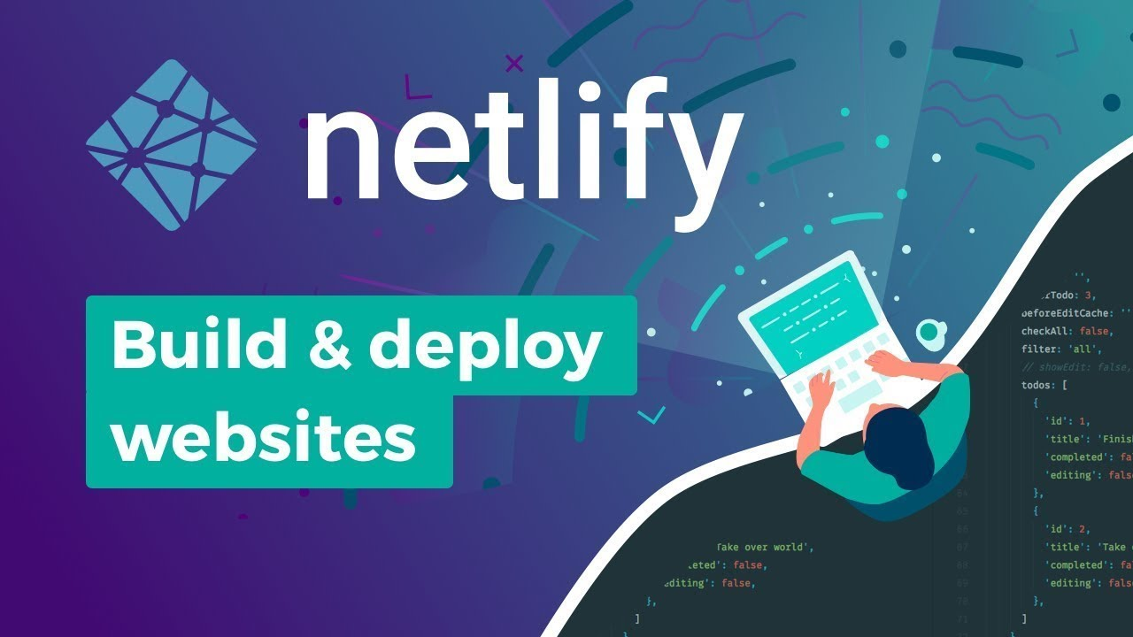

* we will use the domain name <https://sm-wheelchair.netlify.app/>
* we use MySQL For Website Database

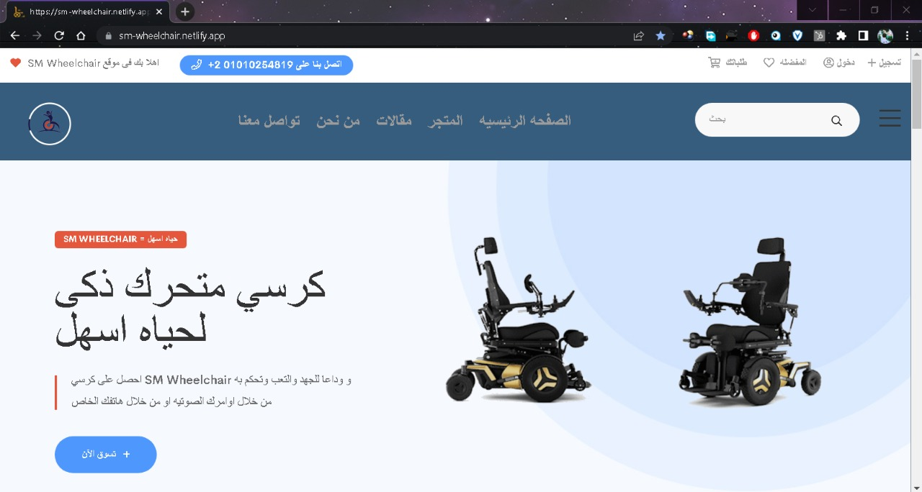

* **The Timeline**

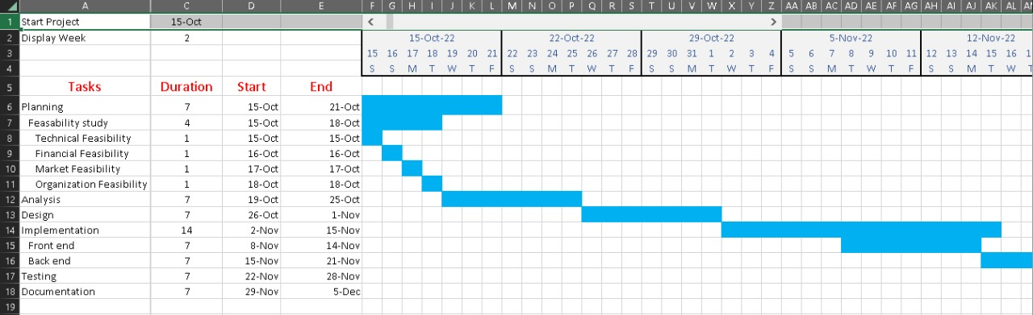

* **FINANCIAL AND ECONOMIC PROJECTIONS**

provides a description of the financial projections

to yield versus additional costs. Financial projections are one key aspect of new project

selection criteria.

(NPV), cost-benefit calculations, and balance sheets are just some examples of how financial.

The financial projections for the addition of an online sales platform for our website are highlighted in the table below.

These figures account for projected online sales, additional staffing requirements, shipping, material, and insurance costs, contract support for IT and training

needs, and web server and hosting costs.

The assumptions for these projections are as follows:

• In store sales projections remain unchanged

• All milestones are performed in accordance with the schedule

• All transactions are closed yearly with no carry-over to subsequent years

|  |  |  |  |  |  |  |
| --- | --- | --- | --- | --- | --- | --- |
| Measure | Year 1 | Year 2 | Year 3 | Year 4 | Year 5 | 5 year total |
| Online Sales Projections | $350,000 | $425,000 | $500,000 | $650,000 | $800,000 | $2,725,000 |
| Additional Staffing Costs | $160,000 | $170,000 | $200,000 | $235,000 | $255,000 | $1,020,000 |
| Projected Material, Shipping, Insurance Costs | $42,000 | $58,000 | $70,000 | $78,000 | $84,000 | $332,000 |
| Additional Web Server and IT Hosting/Maintenance | $22,000 | $25,000 | $30,000 | $35,000 | $40,000 | $152,000 |
| Training for Sales and Marketing Staff | $75,000 | $0 | $0 | $0 | $0 | $75,000 |
| Contract for Design, Build, and Implementation of Online Store | $100,000 | $0 | $0 | $0 | $0 | $100,000 |
| Total Additional Costs for Online Sales | $399,000 | $253,000 | $300,000 | $348,000 | $379,000 | $1,679,000 |
| Cash Inflow | $49,000.00 | $172,000.00 | $200,000.00 | $302,000.00 | $421,000.00 | $1,046,000.00 |

* **FINDINGS AND RECOMMENDATIONS**

Based on the information presented in this feasibility study, it is recommended that website approves the online sales initiative and begins project initiation.

The findings of this feasibility study show that this initiative will be highly beneficial to the organization and has a high probability of success. Key findings are as follows:

Technology:

• Will utilize existing technology which lowers project risk

• Ecommerce infrastructure will be contracted out to vendor which allows website to share risk

• Once in place this technology is simple to operate and maintain for a relatively low cost

Marketing:

• This initiative will allow website to reach large number of target groups electronically at a low cost

• website can expand customer base beyond geographic areas where stores are currently located

• The market for selling medical devices via the Internet is in a steady state of growth

• website is able to differentiate itself from its competitors and will utilize incentive programs to target new consumers

Organizational:

• Minimal increases to staffing are required with no changes to organizational structure

• No new facilities or capital investments are required

Financial:

• Break even point occurs early in the second year of operation

• Five year projections show online sales accounting for 25% of total sales

• website will be in position to capture greater market share by maintaining both an instore and online presenc.

**Design Phase:**

**Coding:**

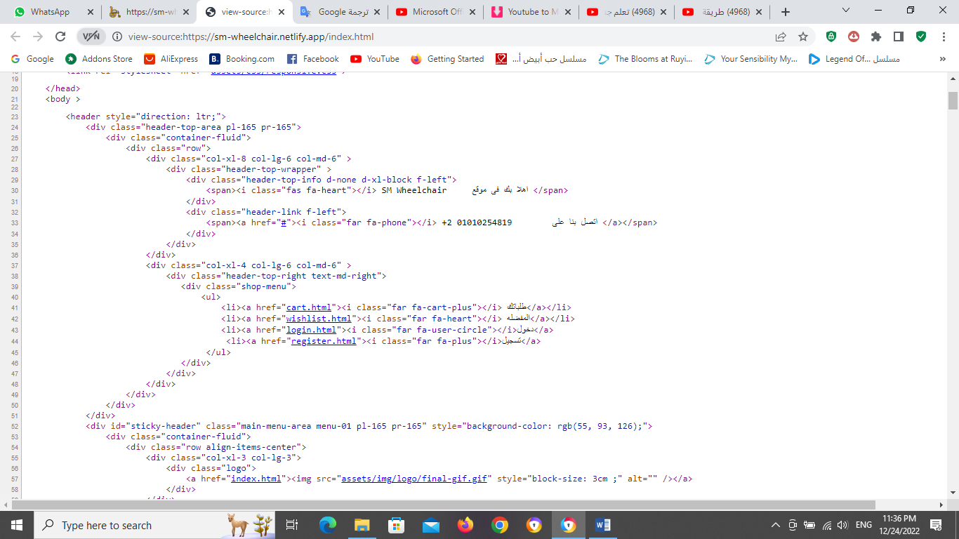

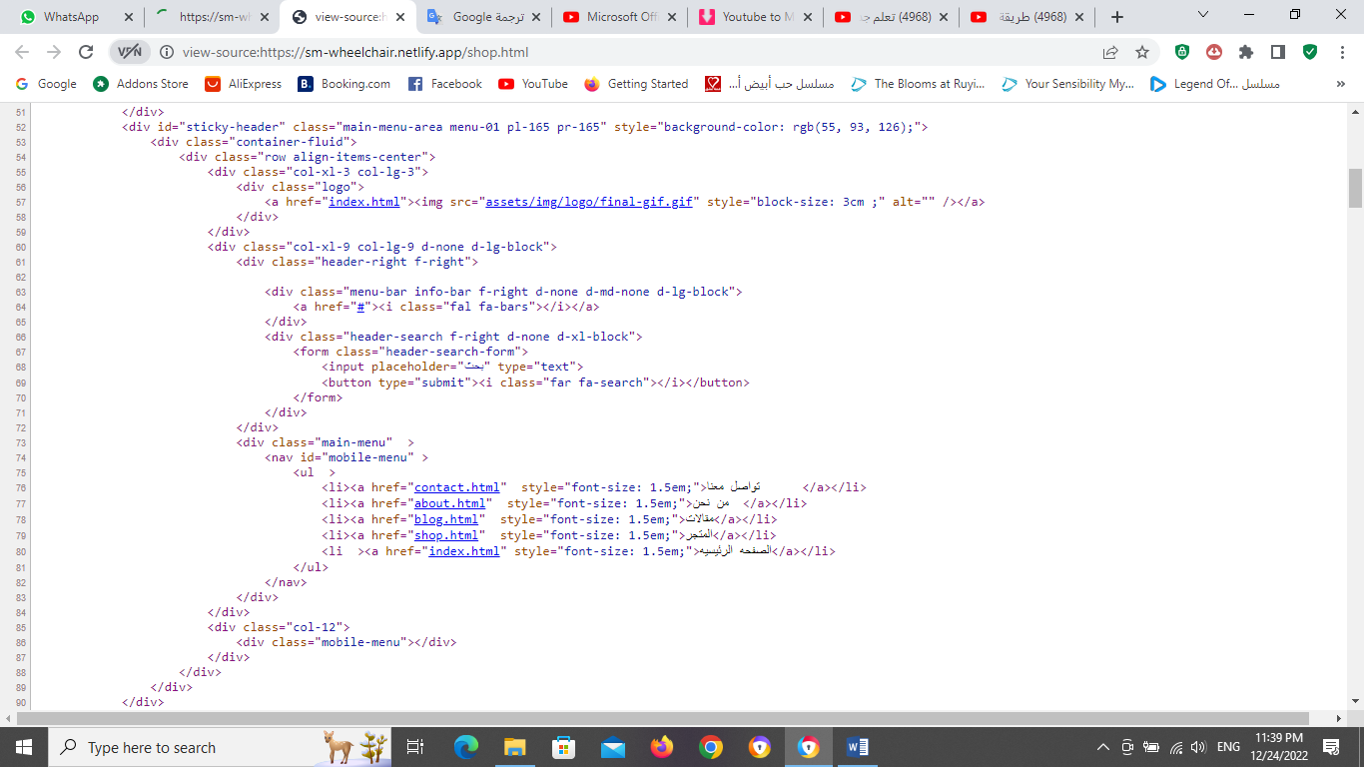

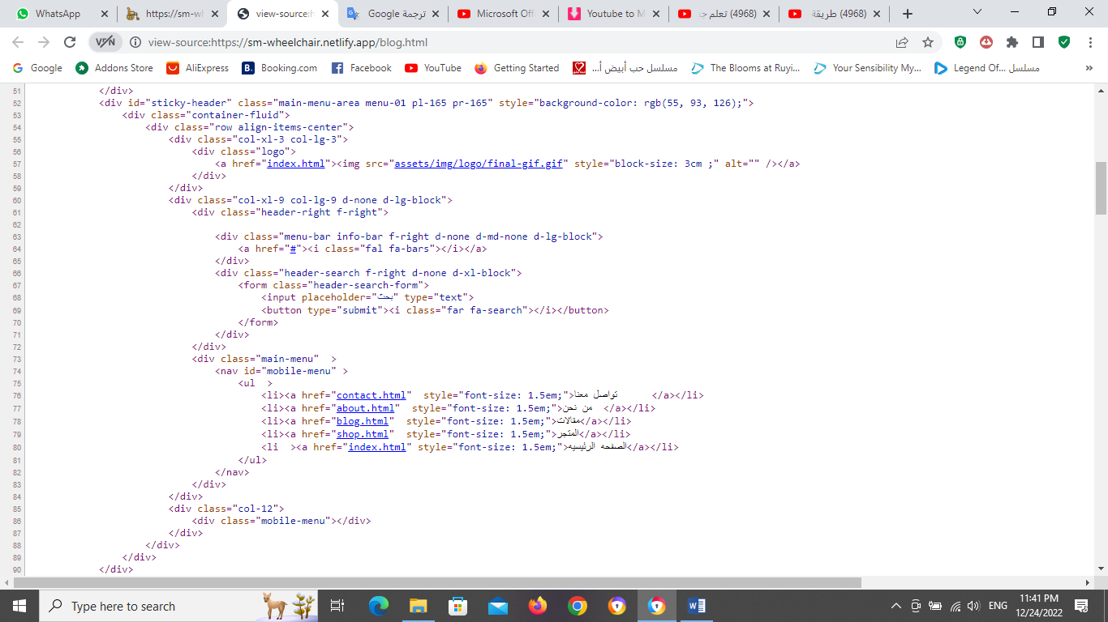

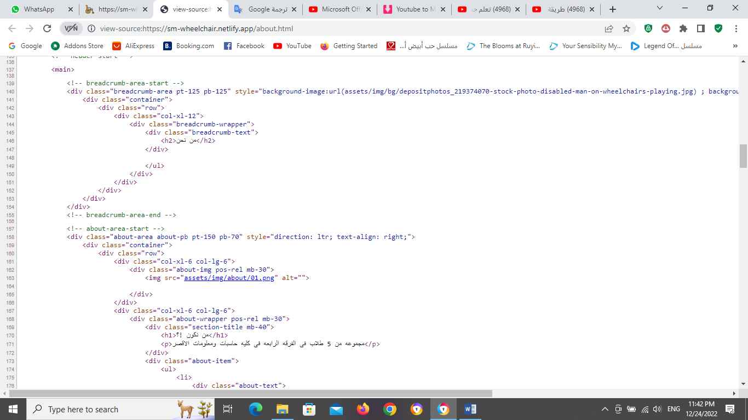

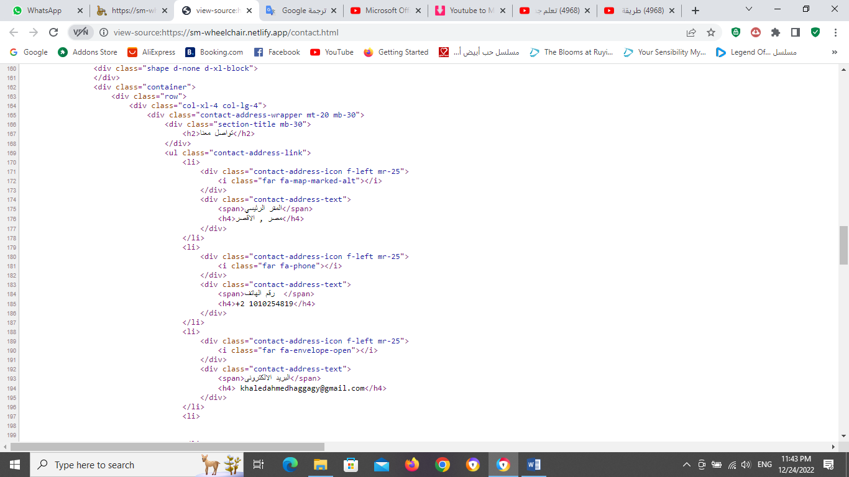

**Design:**

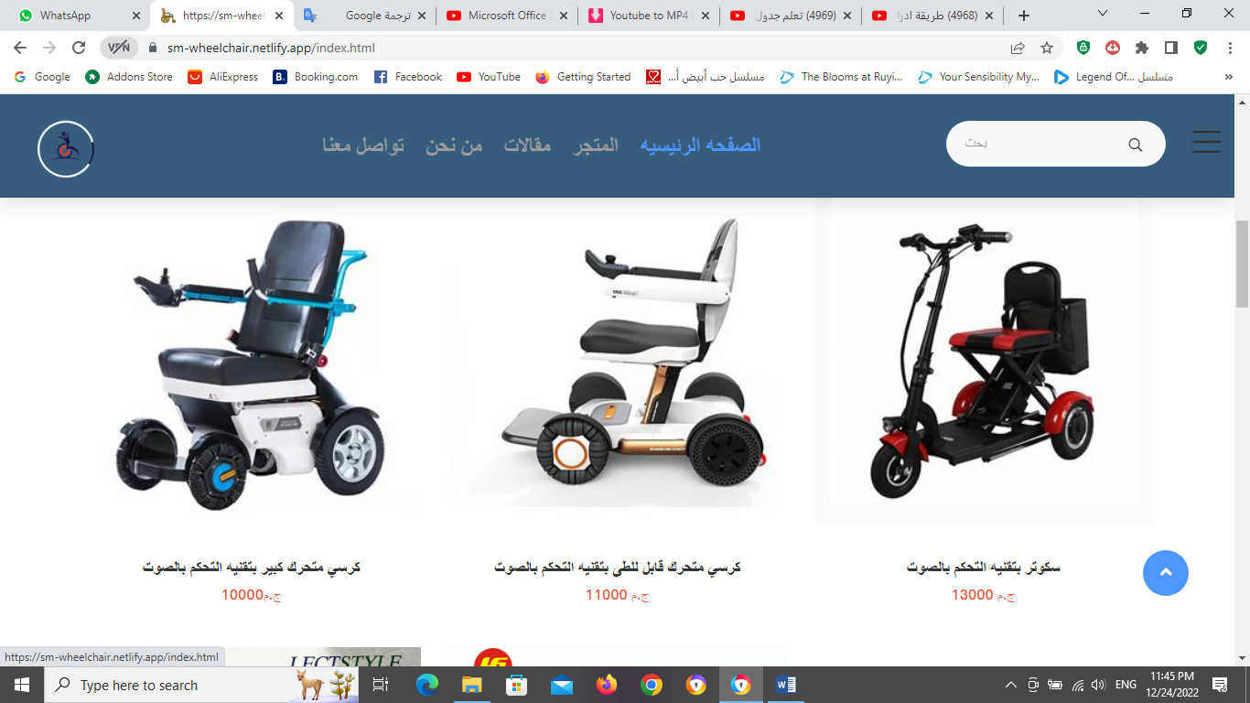

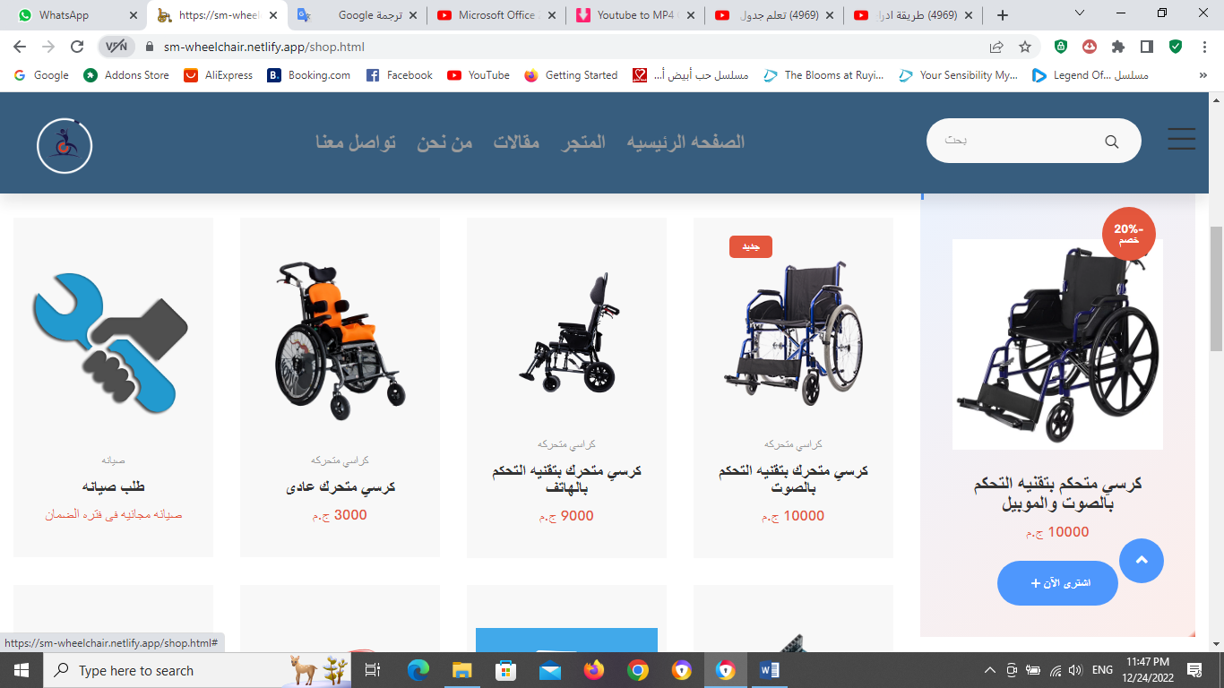

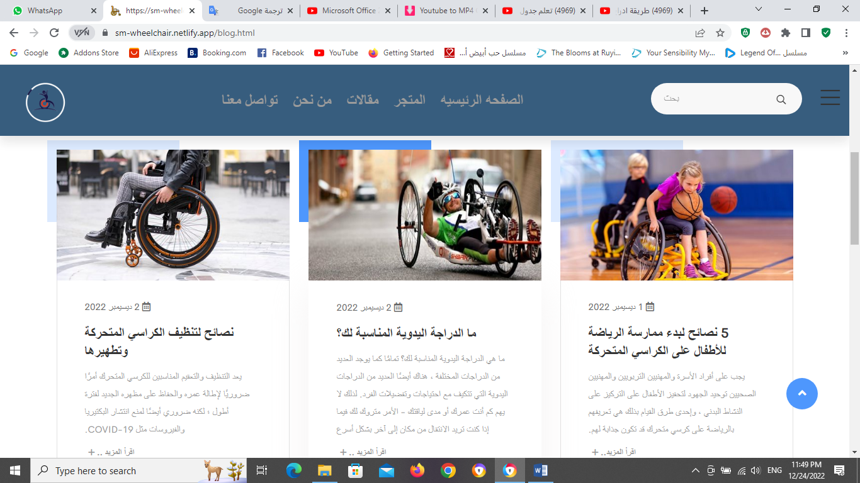

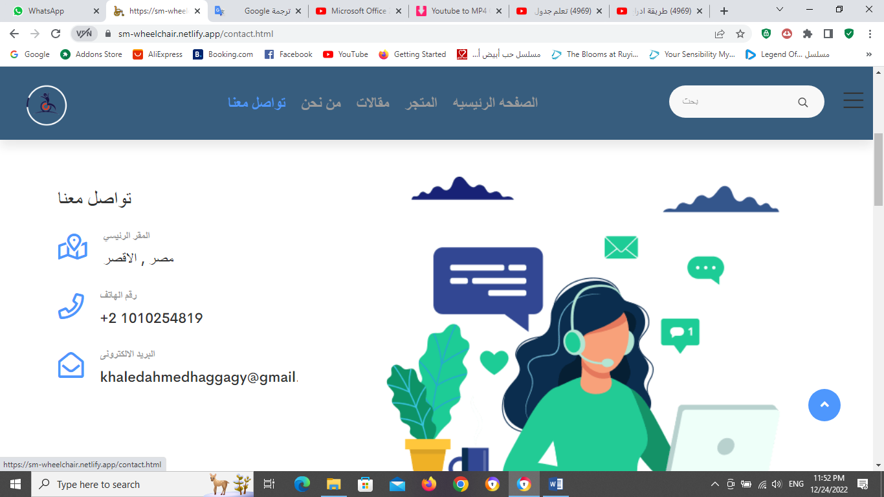

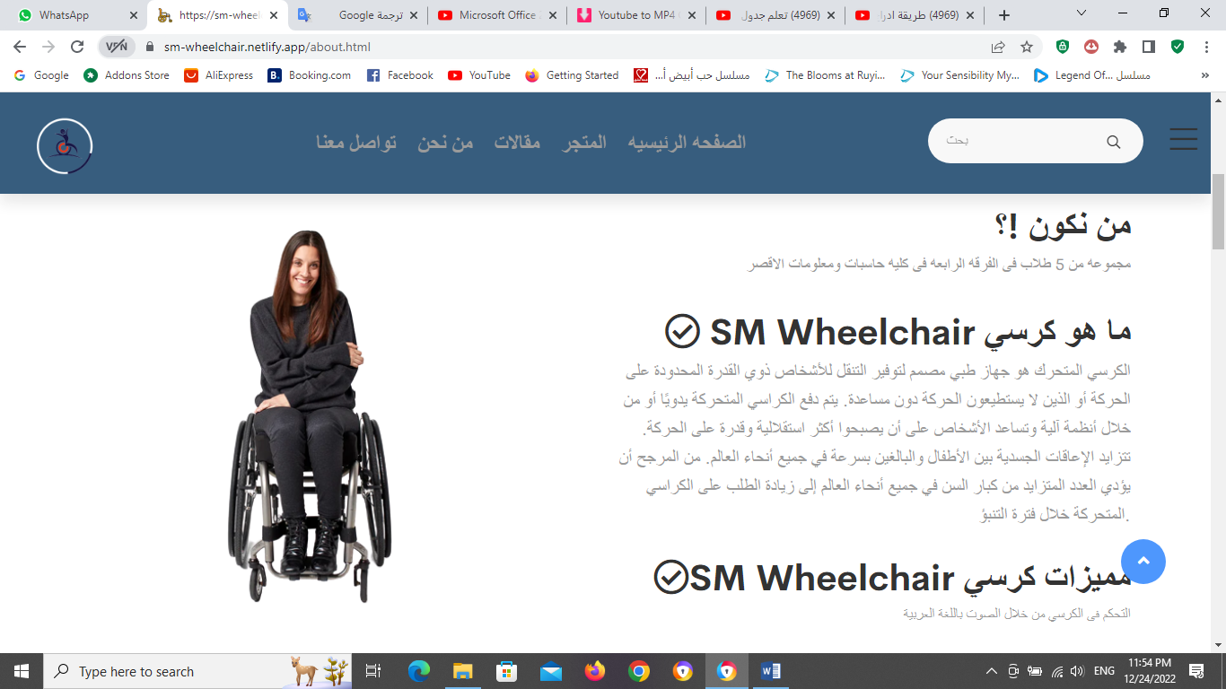

**Analysis phase:**

**Use case diagram:**

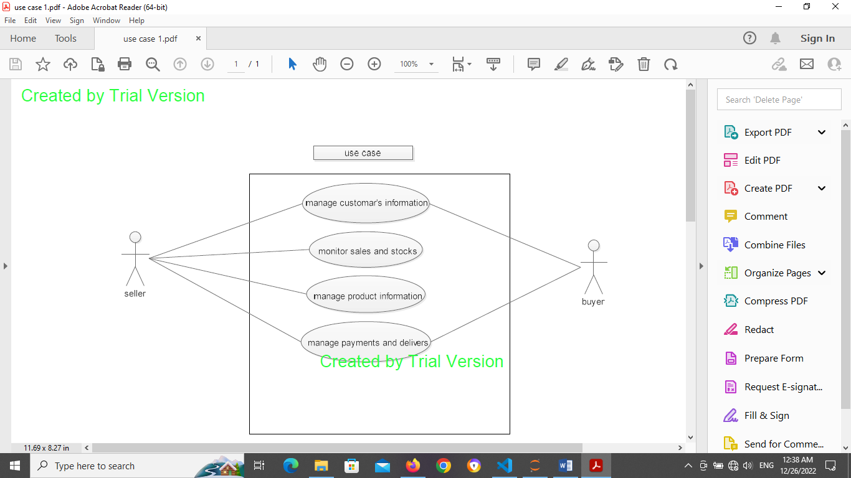

**Class diagram:**

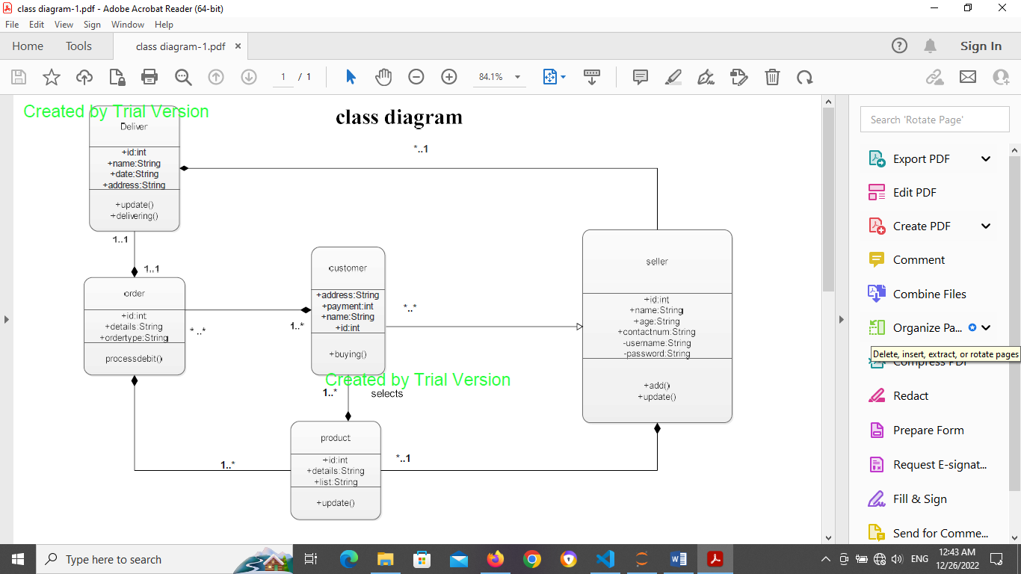

**Sequence diagram:**

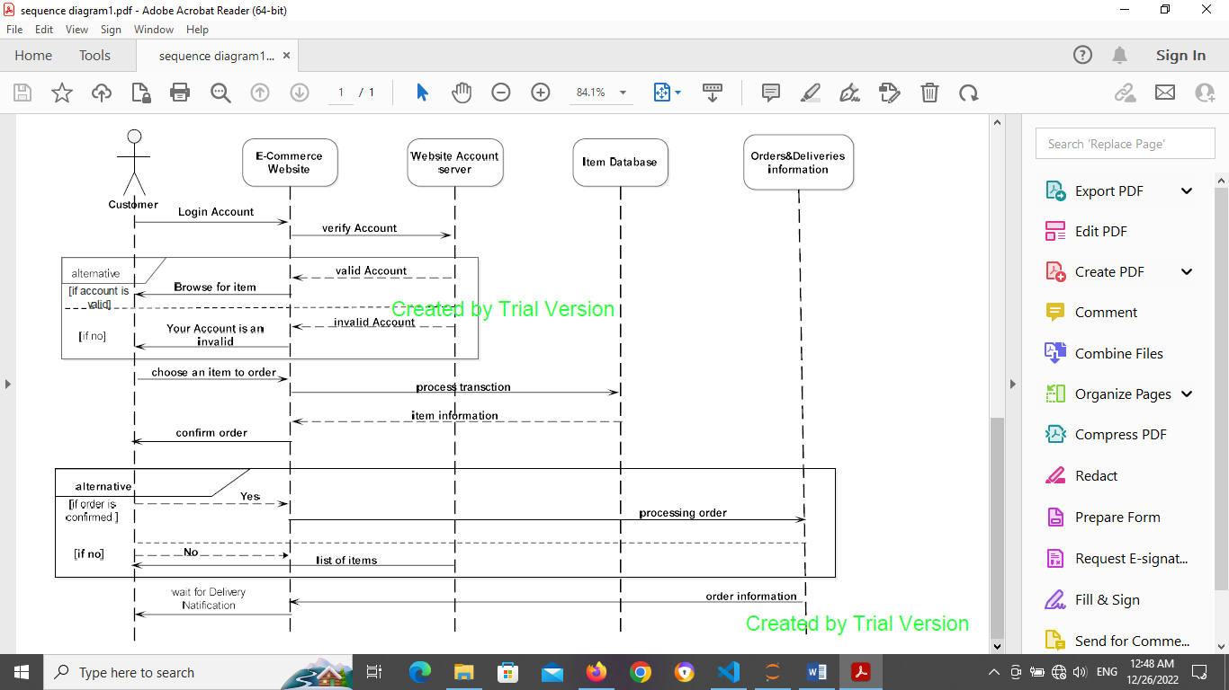

**Activity diagram:**

